Vermot-Desroches Matthias

Rapport de séance n°5

During this session, I started by making a new CAD model on the joint but this time as a female piece in order to replicate the servomotor ensemble that we chose to make.

Here is a reminder of the ensemble:

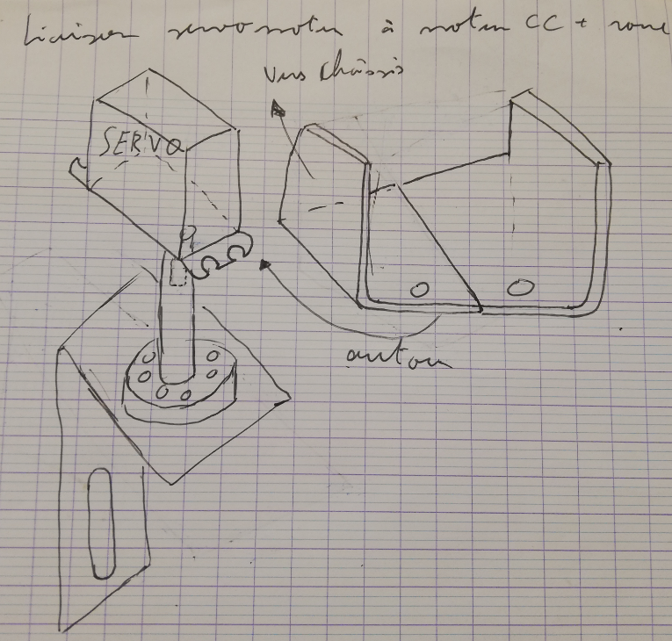

With the new female pieces, the u-shaped plate will be replaced by an ensemble of 2 female + 1 male joint.

Here is a rough sketch of the ensemble:

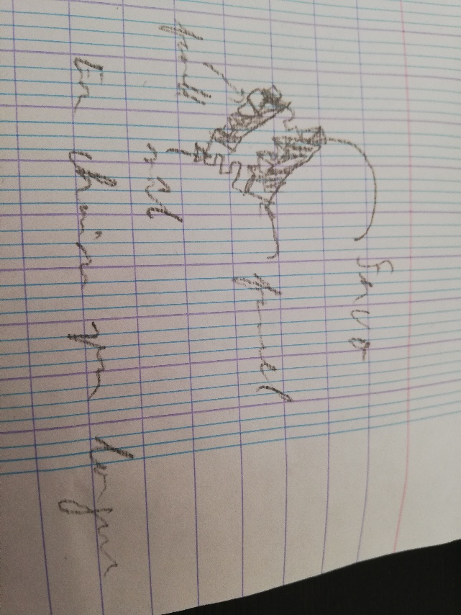

So, I made the CAD model of the female joint, here is how it looks:

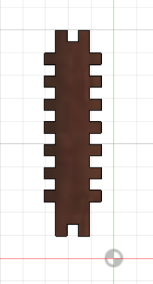

I made the CAD model asymmetrical to balance the fact that the male piece is also asymmetrical.

After that, I used the cutting machine to make the joint and started fixing the wooden base of the robot, the joint were made with 3mm wood:

The first picture here is to illustrate where I put the joint and the second shows how it looks when everything is put together. However, I did not glue the pieces together because there was a problem with the wooden plate. Indeed, they were a little short for the joint and the pseudo-servomotor ensemble to fit.

Moreover, the pseudo-servomotor ensemble was not possible to make with the piece. Here is a picture showing the problem:

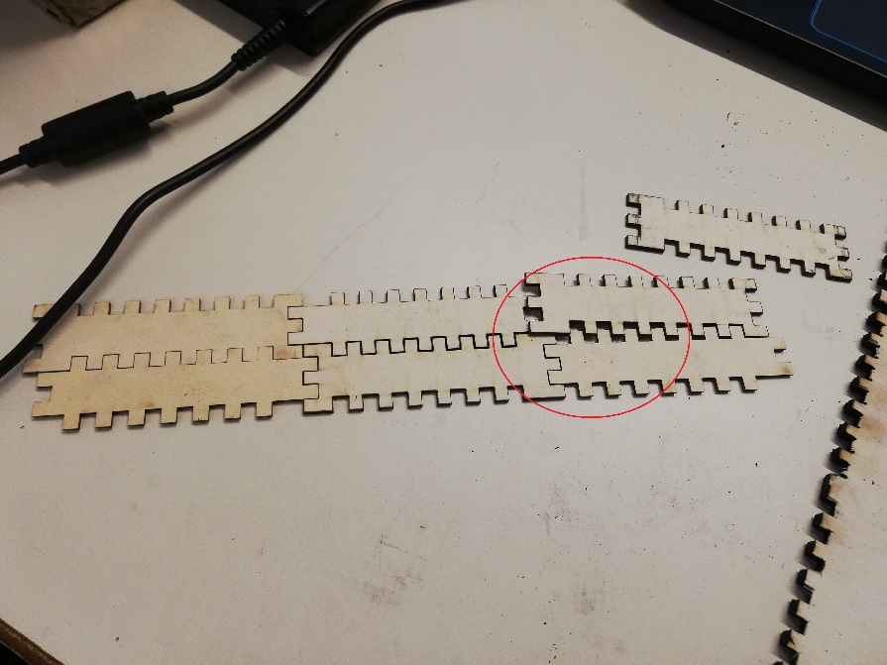

Here, you can see that thanks to the asymmetrical form of the joint, the length of the ensemble cannot be long enough, and it cannot be well fixated and the plate.

So, I made a new CAD model for a new piece (the joint can still be used to fixate the plate, we will have a lot of spare pieces) that I called “chainons” because we will chain them for the servomotor ensemble.

I also made a female and male model:

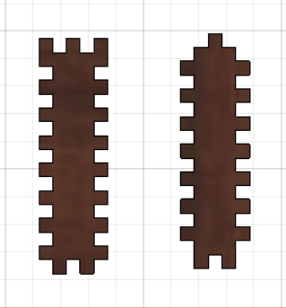

This time, I made them symmetrical and used the “assemblage” function of Fusion 360 to be sure that we will be able to chain them together.

Then, I made them using the cutting machine and 3mm wooden plate:

During the end of the session, I modified the wooden plate model to answer the problem spoken above. Here is the modified model:

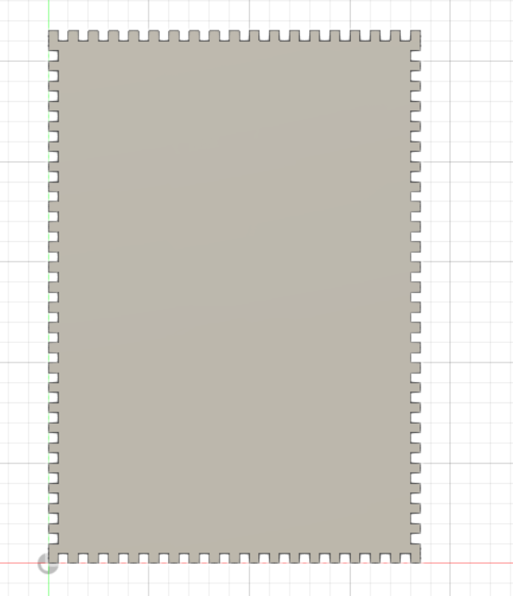

What I modified was the width and length of the plate.